**Task 1**

Pwd – print current working directory.

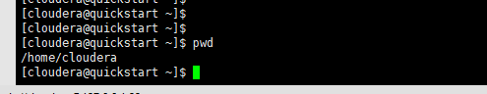

Vi – file editor

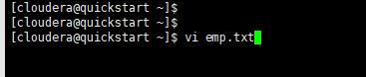

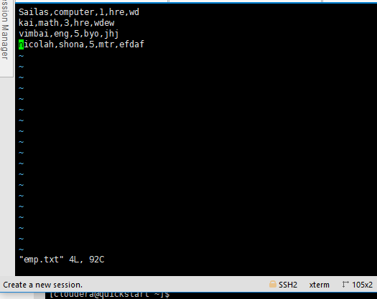

Touch – command to create a new file or modify the timestamp of a file.

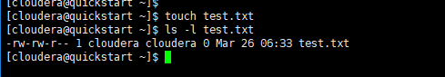

Mkdir – command to create a new directory

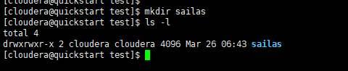

Rm – command to remove a file

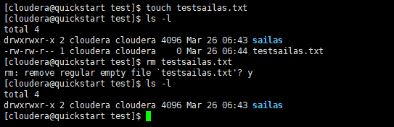

ls – command to list contains of a directory

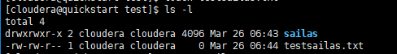

echo – command to print the value of a variable

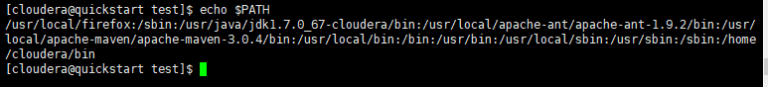

cat – command to list the contains of a file

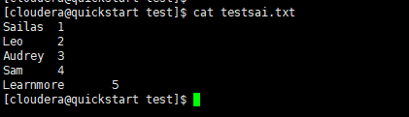

who – shows current login users sessions

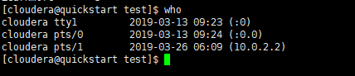

cd – command to change directory

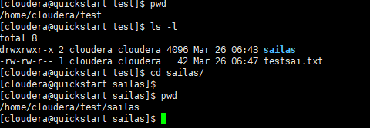

date – prints the date, time and timezone on the system

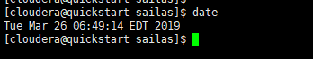

cal – command that shows the calendar and highlights today’s date

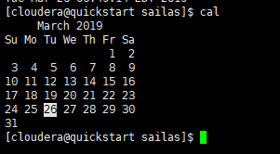

mv – command to move and file from one location to another

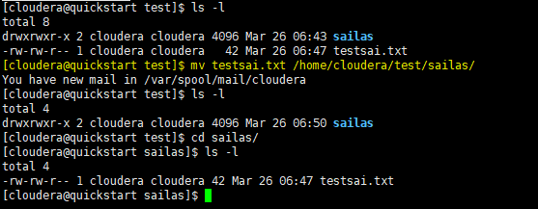

cp – command to copy a file

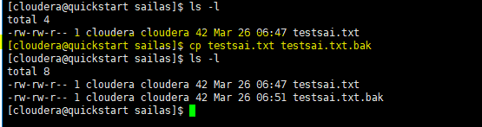

which – command to locate executables on the system.

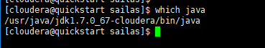

**Task 2**

1. WordMedian

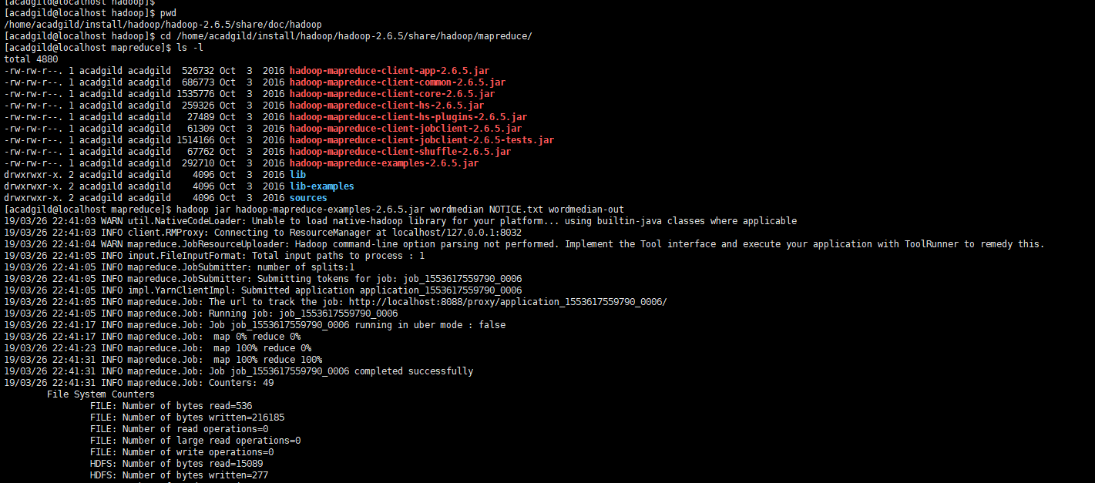

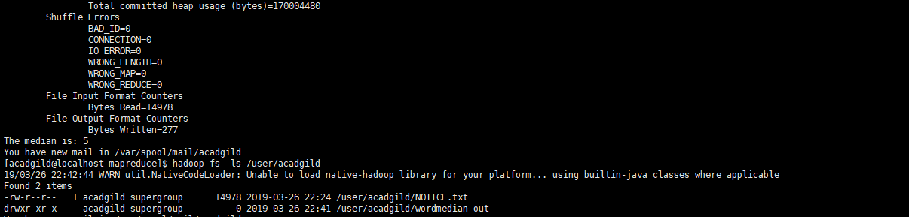

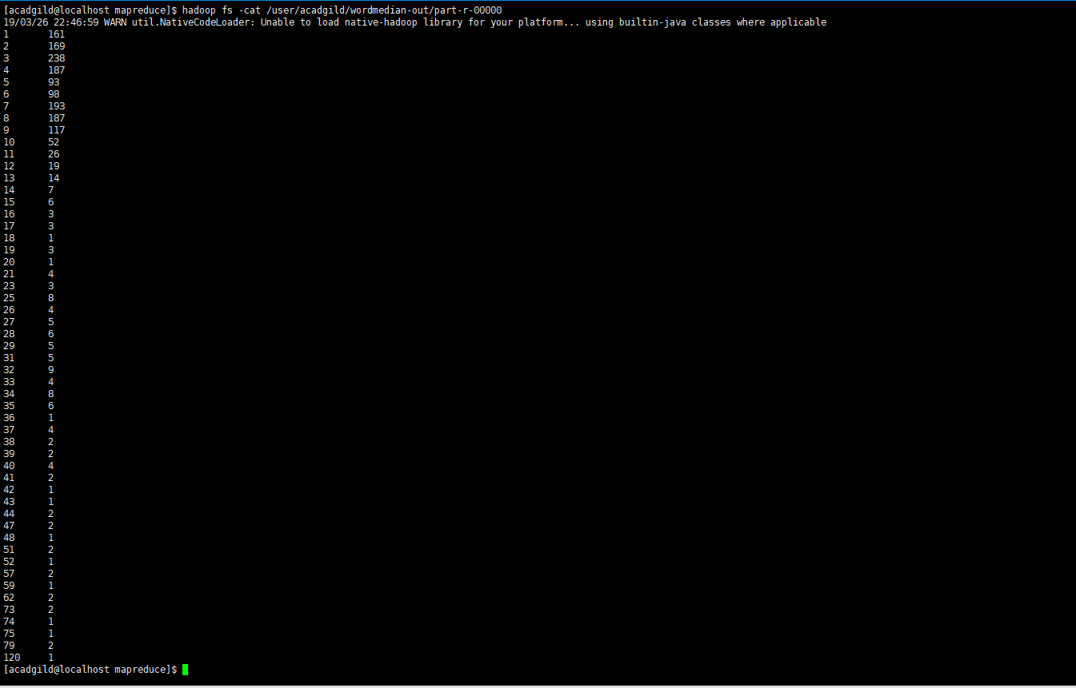

1. WordMean

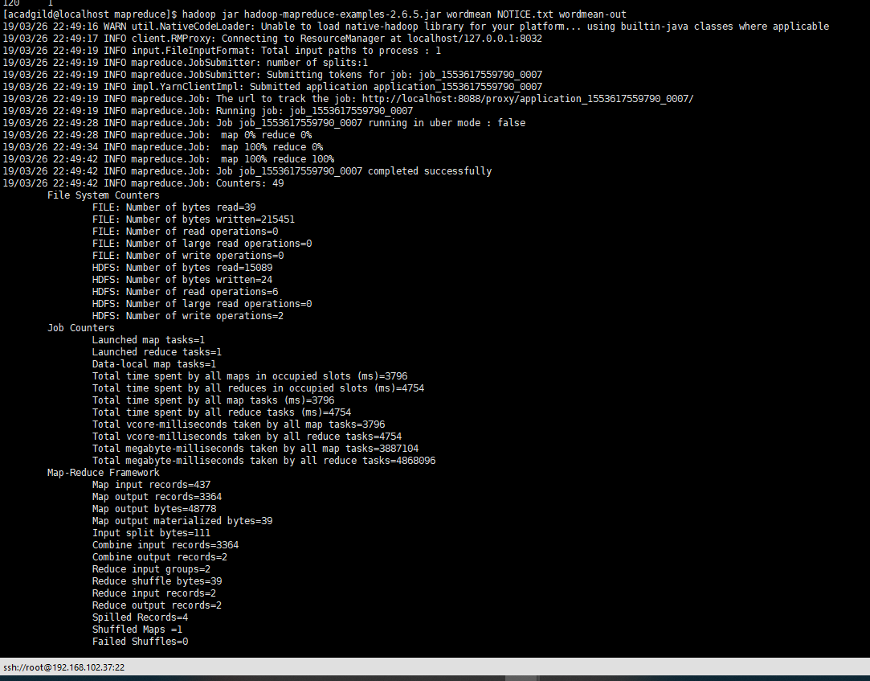

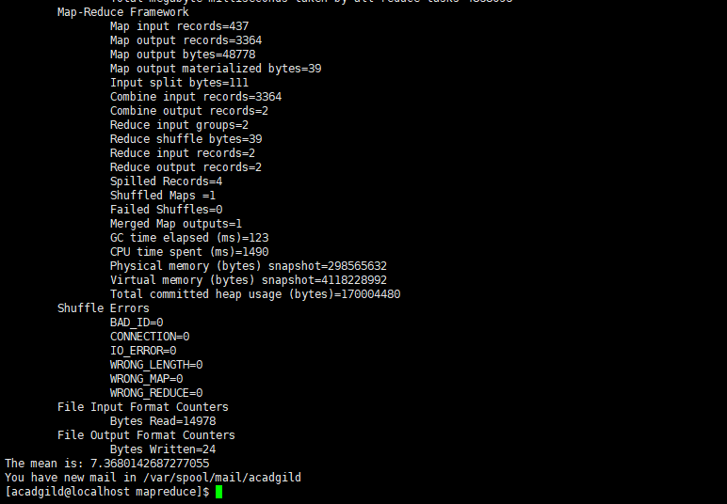

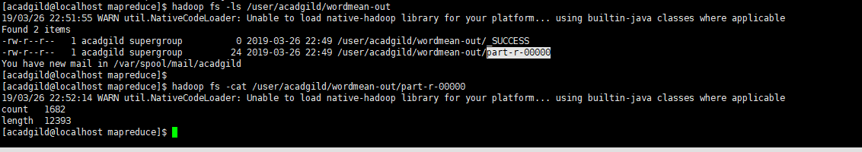

1. WordStandardDeviation

